Resistance Plasmids
Many extrachromosomal elements have been recognized because of their ability to impart new genetic traits to their host cells. One important factor, resistance (R) factor, was first recognized by the fact that organisms in which it was present were resistant to a number of chemotherapeutic agents. A single R factor may carry traits for resistance to as many as seven or more chemotherapeutic or chemical agents. R factors harboured by organisms in the normal flora of human beings or animals may be transferred to pathogenic organisms, giving rise to the sudden appearance of multiple resistant strains.
The R-Factor also called as the resistance factors or resistance plasmids are self-replicating, small, circular DNA elements, that codes for antibiotic resistance. These were first discovered in Japan in the year 1959 when the strains of Shigella (a genus of Gram-negative, aerobic, non-spore-forming, non-motile, rod-shaped bacteria) were found to become resistant to several antibiotics used during a dysentery epidemic.

Structure of Resistance Plasmid
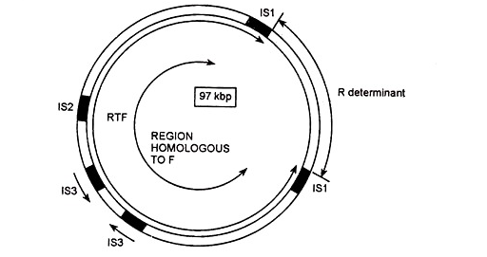
The structure of resistance plasmid can be generally described as a circular piece of DNA, its length ranging between 80 – 95 kb and constitutes the major portion of the R-RTF (Resistance Transfer Factor) molecules. This plasmid is largely homologous to the F factor and contains similar genes. It also contains a fin 0 gene that represses the function of transfer operon. The R factors vary in their size and in the content of genes for drug resistance. The R determinant is smaller than the RTF. Both the RTF and R determinant combine to form one unit and are separated from each other by one IS 1 element on either side. The IS 1 element help in the exchange of R determinant between the different types of R-RTF units.

Gene Amplification
When drugs with low concentration are used to inhibit the growth of the cells containing R-factor, the cells that survive show increased resistance to the drug. This happens due to the duplication of the resistance gene in the R determinant. Recombination occurs between the daughter strands during the replication of R-factor.

Horizontal Gene Transfer
Bacteria containing F-factors can construct a sex pilus which helps in the horizontal gene transfer between the donor bacterium and the recipient bacterium. Antibiotic resistance can easily spread among a bacterial population since many R-factors contain F-plasmids. R-factors can also be taken up by the DNA through transformation or transduction the gene called the Resistance Transfer Factor (RTF) is present in them.

